Contract Number: ${ContractNumber}

Date Fields [edited]
Today | ${Today}
TodayLong | ${TodayLong}
USDate | ${USDate}
UKDate | ${UKDate}
TodayDateOnly | ${TodayDateOnly}
TodayMonthOnly | ${TodayMonthOnly}
TodayYearOnly | ${TodayYearOnly}
Contract/Contracting Party Fields
Contract Number | ${ContractNumber}
Contract Title | ${ContractTitle}
Contract Type | ${ContractType}
Contracting Party | ${ContractingParty}
Contracting Party Company Code | ${ContractingPartyCompanyCode}
Contracting Party Address | ${ContractingPartyAddress}
Contracting Party Address One Line | ${ContractingPartyAddressOneLine}
Contracting Party Primary ContactName | ${ContractingPartyPrimaryContactName}
Contracting Party Primary Contact Email | ${ContractingPartyPrimaryContactEmail}
Contracting Party Primary Contact Business Phone | ${ContractingPartyPrimaryContactBusinessPhone}
Contracting Party Country | ${ContractingPartyCountry}
Contracting Party City | ${ContractingPartyCity}
Contracting Party State | ${ContractingPartyState}
Contracting Party Zip Code | ${ContractingPartyZipCode}
Description | ${Description}
Department | ${Department}
Effective Date | ${EffectiveDate}
Expiry Date | ${ExpiryDate}
Risk Level | ${RiskLevel}
Renewal Term | ${RenewalTerm}
Contract Value | ${ContractValue}

Check Box Customization for Contract Generation
New checkbox | ${Newcheckbox}
New checkbox  value only | ${NewcheckboxValueOnly}
New checkbox  boolean | ${NewcheckboxBoolean}
New Checkbox  KeyValue | ${NewcheckboxKeyValue}
New Checkbox | ${NewcheckboxKeyValueOneLine}

Checkbox Custom Field Definition (See New checkbox below with option value defined):
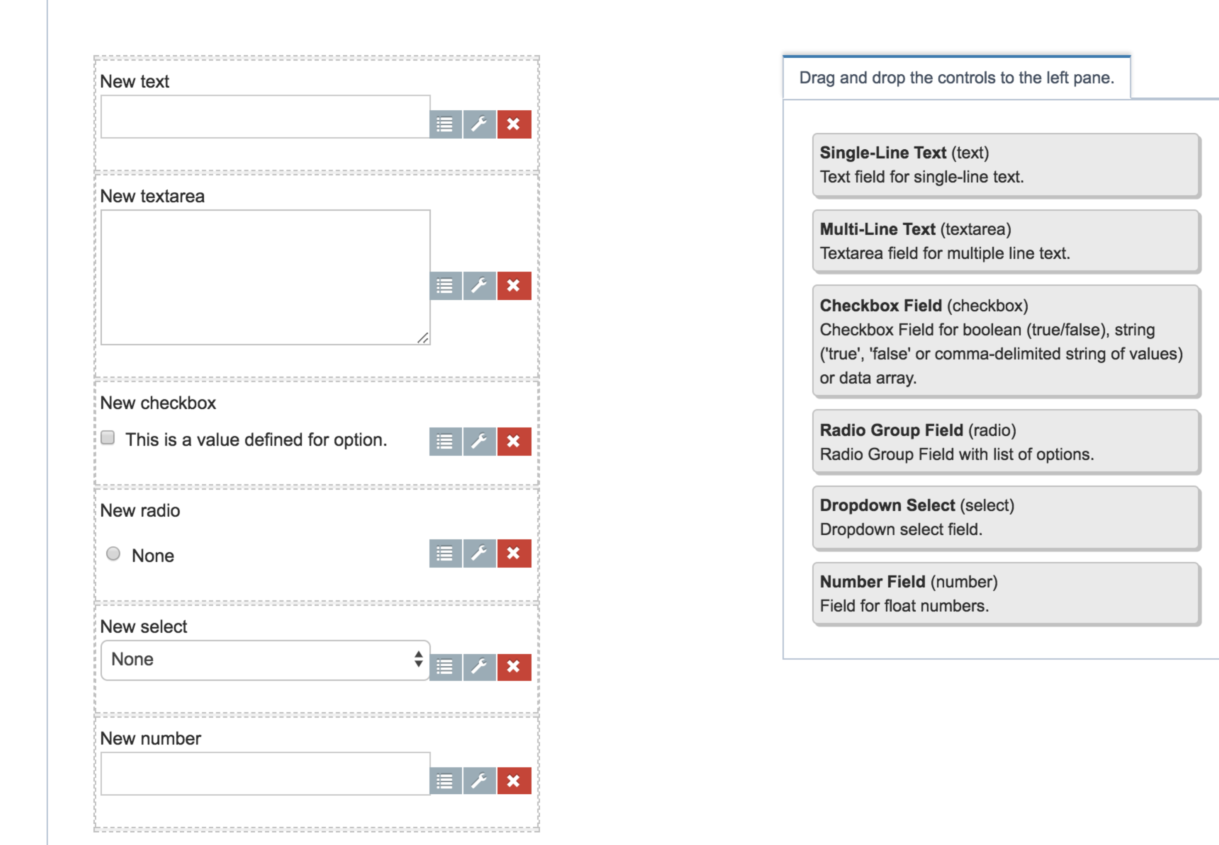
Key = Checkbox Label
Value = Option Label Field Entry
Click Checkbox second button and add value to the Option Label field.:
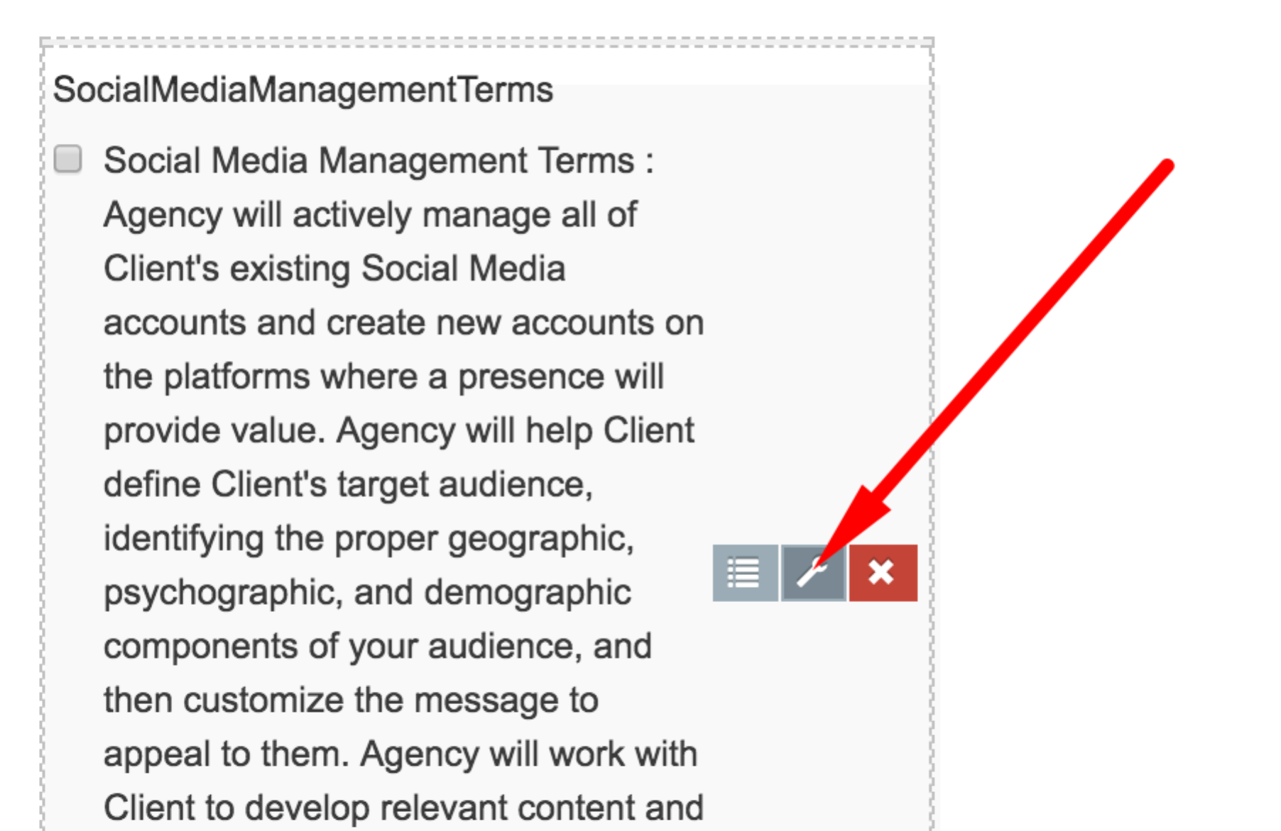
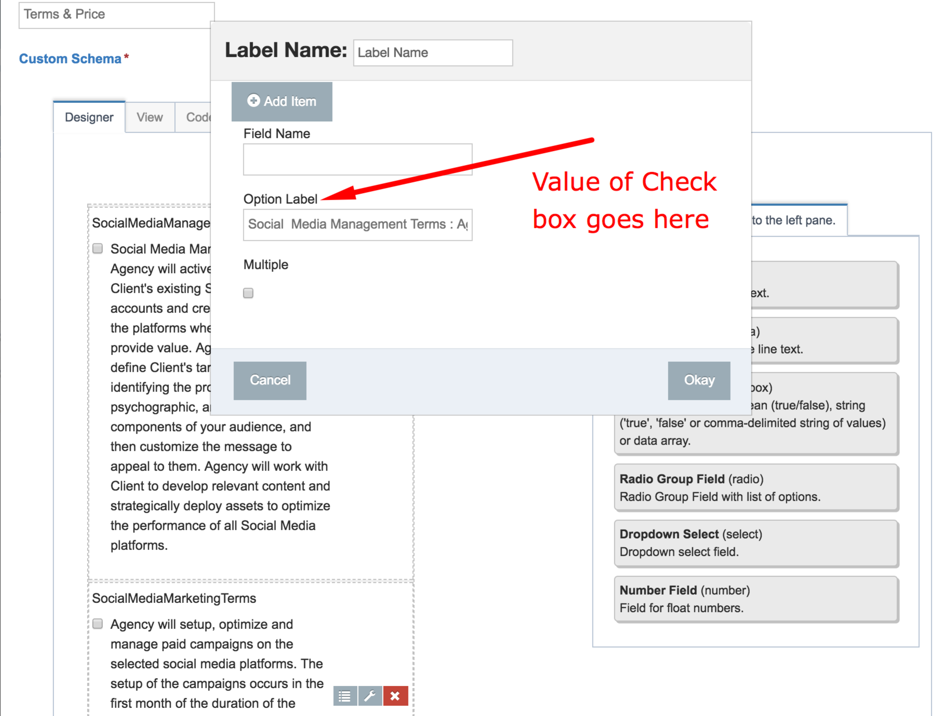

Drop Down Customization for Contract Generation
New select | ${Newselect}

Radio Button Customization for Contract Generation
New radio | ${Newradio}

Number Field Customization for Contract Generation
New number | ${Newnumber}

${TodayLongFR}
${TodayMonthOnlyFR}
${EffectiveDateLongFR}
${EffectiveDateMonthOnlyFR}
${ExpiryDateLongFR}
${ExpiryDateMonthOnlyFR}

